Request for Quotation

FROM | NORWEGIAN REFUGEE COUNCIL
Address | Hay El Matar, Port Sudan, Sudan
City | Port Sudan
Country | Sudan
Phone # | +249 91 12520218
Email | sd.procurement@nrc.no asmaa.mohammed@nrc.no noon.abdalla@nrc.no
TO | Kindly fill this information

Company Name

Address

City

Country

Phone #

Email

The office of the Norwegian Refugee Council invites your company to submit a price quotation for the following items in accordance with the requirements detailed below. You may use your company format, or fill up the table below. Please read carefully the instructions on page 2.

Request for Quotation Requirements
RFQ # : | PF-KRT-866 | Currency | USD - SDG
RFQ Issuing Date: | July 27, 2023 | Bid Validity Period (days): | Preferably 30 days
RFQ Closing Date: | July 29, 2023 | Required Delivery Date: | Aug 2nd , 2023
RFQ Closing Time: | 03:00 PM (GMT +2) | Required Delivery Destination: | Hay El Matar, Port Sudan, Sudan
Questions to the RFQ | sd.procurement@nrc.no asmaa.mohammed@nrc.no | Required Delivery Terms: | DAP (INCOTERMS 2020)

To be filled by NRC |  |  |  | To be filled by Supplier
Item  # | Description/ Specifications | Unit | Quantity Required | Unit Price | Total Price
1 | Electric Self-Priming Fuel Transfer Pump Automatic Diesel Transfer Pump 60L/MIN – Fuel Pump 220 V , Voltage 12V/24/220V – Power 550 w, Traffic: 60L/Min , Head 15 m , suction: 5 m , Gross weight : 18KG, Working Presure : 0.3mpa | Pc | 1
2 | Blue 200 Liter Empty Mild Steel Barrel, For Fuel, Capacity: 200-220 Litre | Pc | 5
3 | delivery & Installation of Fuel Pump to NRC Office – Port Sudan | Work | 1
GRAND TOTAL (Including Transport and VAT)

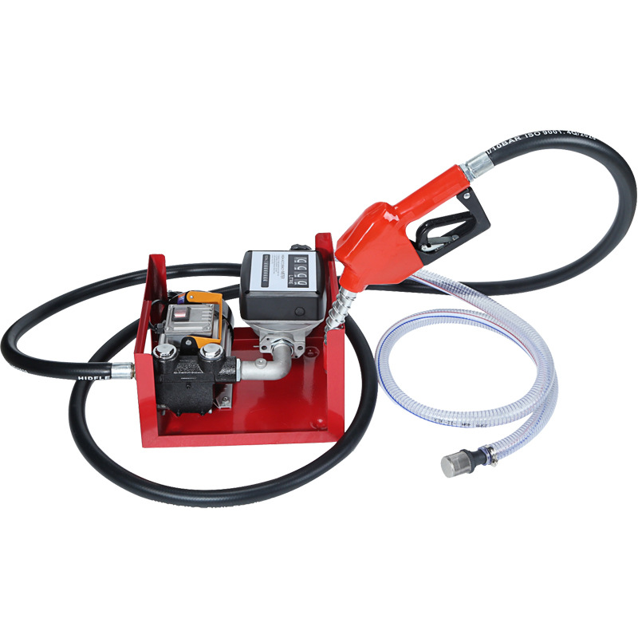

What is the currency of the quote?

DO NOT PROVIDE QUOTES IN BOTH SDG AND USD CURRENCIES.

Delivery Lead Time (in days, from receipt of NRC Purchase Order)

Bid Validity Period (in days from receipt of NRC Purchase Order):

Warranty:

- Explain the length of the warranty

- Explain what is covered by the warranty

- Explain how the maintenance should be handled during the warranty period (ex : done by the supplier’s team…)

Please provide as much details as possible.

Country of origin of the goods

Please confirm the following payment terms:

100% After Delivery

(No Advance payment can be issued)

What is the brand of the Fuel Pump?

Please provide photo or brochure or website. (Mandatory)

Do you have all the items in stock?

What is the delivery time (on site)?

(Please specify delivery schedule if any)

NRC Prefer the item to be in stock and delivery within 2 days ).

Expected delivery date for Air Condition to Port Sudan – Hay Al Matar within 2 days Maximum

Name

Position

Date Signature

Stamp

RFQ Terms & Conditions
Manner of Submission:
- By hand in a sealed envelope to NRC office located Port Sudan , Hay El Matar
- By email to the dedicated and secured email address: sd.procurement@nrc.no asmaa.mohammed@nrc.no (offers received on other email addresses will not be considered)
- Before the Closing date & Time mentioned above. Companies who do not submit their quotation by this deadline will not be considered

Requirements:
- All Bids must include all customs and taxes payable in the country of delivery unless the RFQ specifically requests differently
- Bids must be submitted in the currency indicated in the RFQ. Bids in other currency might not be accepted
- Bids must be valid for the validity period indicated in the RFQ. Bids not meeting this validity period might be disqualified
- All enquires and questions should be addressed to the email given in the RFQ details section. All questions and answers will be shared with all invited suppliers.
- NRC reserves the right to accept or reject the whole or part of your quotation based on the information provided. Incomplete quotations which do not comply with our conditions will not be considered.
- Provide Catalogue for the items listed in annex, together with your offer (if relevant)

check that you are providing all the below mentioned documents:

Mandatory documents | Checked (Y/N)
Company registration certificate
Company tax registration certificate
NRC Request for Quotation (filled up, signed and stamped)
Additional quotation on company letter head document, if any…
Technical description / catalogue
Capacity & Lead Time

Assessment Criteria:
- All bids received and accepted will be evaluated based on the following:
- Step 1: Administrative compliance check: Each bid will be checked to ensure compliance with all the RFQ requirements
- Step 2: Technical Evaluation: All bids will be technically evaluated based on “best value for money”
- Step 3: Financial Evaluation: Price in comparison to NRC established expectation and in comparison, to other bidders of comparable technical quality

Payment terms:
- Payment will be made within 30 days of receipt of goods, by bank transfer/cheque only.

NRC is obliged to ensure that its procurement decisions are clearly justified and documented and keeping within the Donors mandatory principles. In that regard, full and on-the-spot access must be granted to representatives of NRC, the Donor or any organisation or person mandated by it, to premises belonging to NRC or its contractors. The right to access shall include all documents and information necessary to assess, or audit the implementation of the contract.  NRC also expects suppliers who process personal data to comply with the General Data Protection Regulation (EU GDPR) and any relevant national legislation. Suppliers processing personal data on an NRC contract will be required to sign a data processing / sharing agreement as part of the contract. Refusal to sign such an agreement constitutes refusal of the contract terms and forfeiture of the contract on the part of the supplier.  If the activities of the contract take place in areas with Explosive Hazards, NRC accepts no liability for injury and/or death to contractor’s staff or damage to contractor’s property. | Anti-money laundering, anti-bribery, anti-corruption and anti-terrorism legislation and donor regulations require NRC to screen contractors against various international lists to ensure due diligence. Submission of the quotation constitutes acceptance of these screening practices.  NRC aims to purchase products and services with minimum environmental impact. Environmental considerations form part of the NRC selection criteria, and NRC reserves the right to reject quotations provided by suppliers not meeting these standards.  All suppliers doing business with NRC should maintain high standards on ethical and environmental issues, respect and apply basic human and social rights, ensure non-exploitation of child labour, and give fair working conditions to their staff. Suppliers will be required to sign and submit an Ethical Standards Declaration, together with their bid.  NRC reserves the right to reject quotations provided by suppliers not meeting these standards.
Signature & Stamp

